## PRACTICAL EIGHT: READING DATA INTO SPSS

1. GENERATE 2 DATA CELLS FROM DIFFERENT SURVEYS
2. ENTER DATA 1 DIRECTLY INTO SPSS AND HIGHLIGHT ALL THE STEPS TAKING IN ENTERING YOUR DATA.

After opening the SPSS application, click on Control and N together to start a new data. Then follow the following steps:

* Click the variable view tab at the bottom of the Data Editor window.
* In the first row of the first column, type MatricNumber.
* In the second row, type Scores.

You observe that the names that you entered in variable view are now the headings for the first three columns in Data View. Then begin entering in the first row, starting at the first column;

* Click the variable view tab at the bottom of the Data Editor window.
* In the Decimal column of the MatricNumber row, type 0 to hide the decimal.
* In the Decimal column of the Scores row, type 0 to hide the decimal.

Then go back to Data View to input your data to the rows.

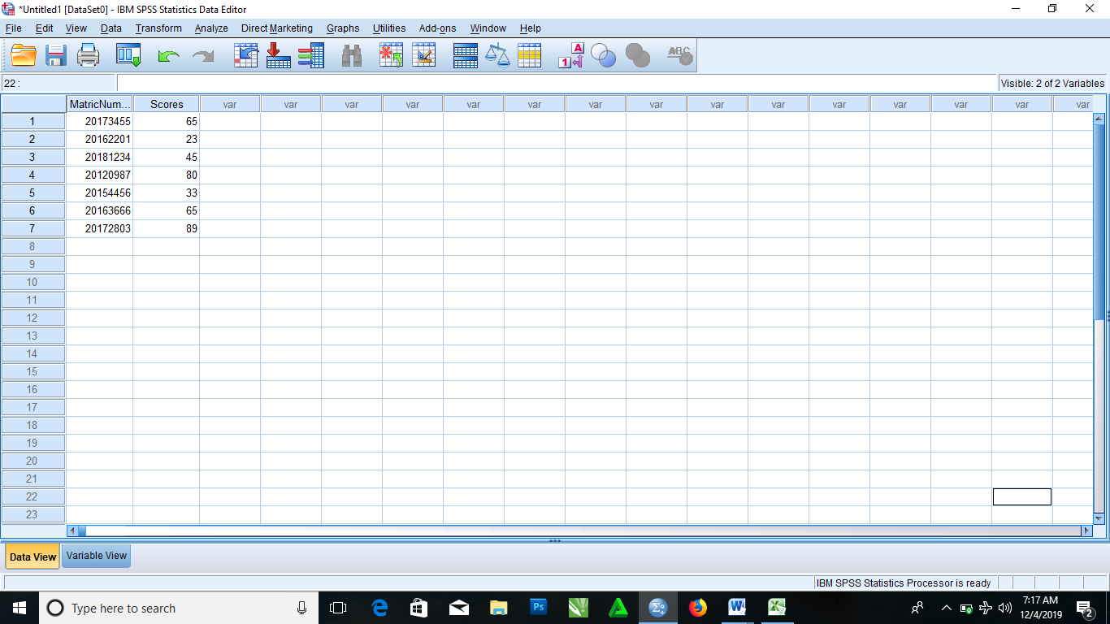

1. ENTER DATA 2 INTO MICROSOFT-EXCEL AND IMPORT SAME DATA INTO SPSS AND GIVE ALL THE NECESSARY DETAILS FOR IMPORTING THE DATA INTO SPSS.

* From the menus choose

File > Open > Data……

* Then select Excel(*.xls) as the file type you want to view
* Then open demo.xls

The opening Excel data source dialog box is displayed, allowing you to specify whether variable names are to be included in the spreadsheet as well as the cells that you want to import

* Make sure that Read Variable names from the first row of data is selected. This option reads column headings as variable names

NOTE: If you want to import only a portion of the spreadsheet, specify the range of cells to be imported in the range text box

* Click OK to read the Excel File

Then the data now appear in the Data Editor, with the column headings used as variable names.

NOTE: Since variable names can’t contain spaces, the spaces from the original column headings have been removed. The original column heading is retained as a variable label.

